**LedStrip**

|  |  |
| --- | --- |
| Author | Bo Mengels |

Content

1 Introduction 1

2 Material and methods 2

3 Results 2

3.1 Subtitle 1 2

3.1.1 Subtitle 2

3.1.2 Subtitle 2

3.2 Subtitle 2 2

3.2.1 Subtitle 2

3.2.2 Subtitle 2

4 Discussion 2

5 Reference list 2

# Introduction

[Describe your project:

* What did you build?
* What are the main characteristics of the device?
* What does it do?
* What is the reason you chose to build this device?
* What is your starting point? Are there any (scientifically-) related articles you used?
* Give an overview of the different topics you discuss in the Application Note.

Mind your writing style: do not write: “I had to do this for the course ‘Project Design.’ Instead use objective and informative sentences using the correct tense (Simple Present). Never use subjective expressions nor personal pronouns (I, we, you). Do not address the reader. Focus on the research: describe the situation and the process.

**+/- 100 words**]

The project is series of LED matrices that are 8 x 8. Through wi-fi the user can type a sentence or a word and after the text will appear on the LED matrices. The device exist out of a PCB and 8 LED matrices. The device is connected to Wi-fi with the use of a esp-12 component. To start with the project an elector magazine was used. In this magazine the whole design and component list was written. There is a step by step explanation on how the device must be build and how it needs to be programmed.

# Material and methods

[Give an overview of the materials and the methods you used:

Materials: the components for the device

* Which materials (i.e. hardware and software) did you use and did you compare?
* Which materials were not useful and why not? Use proper, objective evaluation criteria.
* Add the Bill of Materials including an indication of the price, supplier name and delivery date (table in English!)

Methods: specific tools and procedures you use to collect and analyze data (for example, experiments, datasheets…)

* Include a schematic representation (i.e. flowdiagram) and explain this representation by providing a step by step overview of the design process, production process and testing process (including a description of the mechanical design).

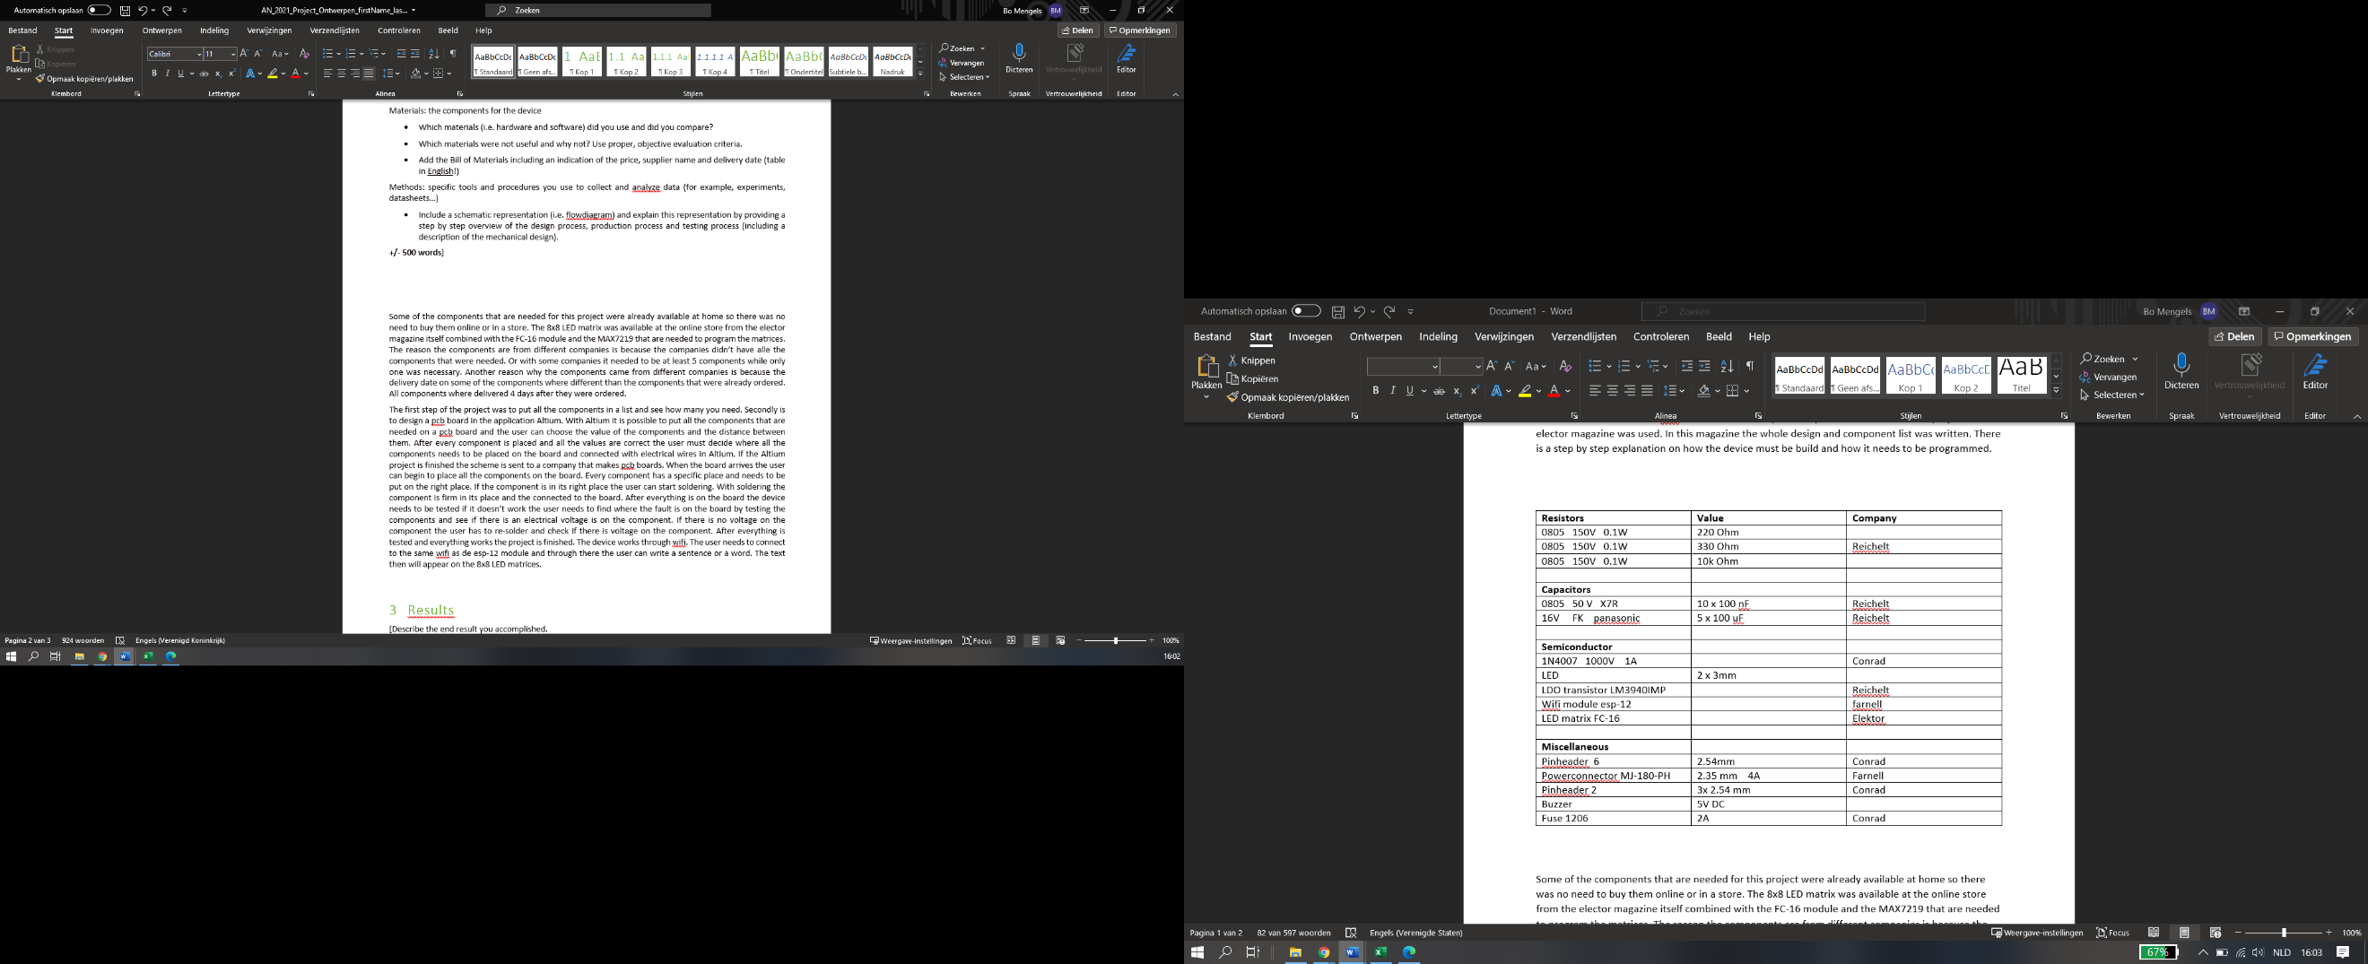**+/- 500 words**]

Fig.1 Material list

Some of the components that are needed for this project were already available at home so there was no need to buy them online or in a store. The 8x8 LED matrix was available at the online store from the elector magazine itself combined with the FC-16 module and the MAX7219 that are needed to program the matrices. The reason the components are from different companies is because the companies did not have all the components that were needed. Or with some companies it needed to be at least 5 components while only one was necessary. Another reason why the components came from different companies is because the delivery date on some of the components were different than the components that were already ordered. All components were delivered 4 days after they were ordered.

The first step of the project was to put all the components in a list and see how many there are needed. Secondly is to design a PCB board in the application Altium. With Altium it is possible to put all the components that are needed on a PCB board and the user can choose the value of the components and the distance between them. After every component is placed and all the values are correct the user must decide where all the components needs to be placed on the board and connected with electrical wires in Altium. If the Altium project is finished the scheme is sent to a company that makes PCB boards. When the board arrives the user can begin to place all the components on the board. Every component has a specific place and needs to be put on the right place. If the component is in its right place the user can start soldering. With soldering the component is firm in its place and then connected to the board. After everything is on the board the device needs to be tested if it does not work the user needs to find where the fault is on the board by testing the components and see if there is an electrical voltage is on the component. If there is no voltage on the component the user has to re-solder and check if there is voltage on the component. After everything is tested and everything works the project is finished. The device works through wi-fi. The user needs to connect to the same wi-fi as de ESP-12 module and through there the user can write a sentence or a word. The text then will appear on the 8x8 LED matrices.

# Results

[Describe the end result you accomplished.

* Describe every aspect of your device. How does it function?
* Add an image of the electrical schematic, PCB design, finalized mechanical design, and finalized product

Write a well-structured text using subtitles and paragraphs.

**+/-500**]

## Description

### Aspects

#### Driver

Every led-matrix is concluded with a MAX7219-driver. The driver takes care of the communication between de microcontroller and the 64 LED’s on the 8x8 LED matrix.

#### Software

The program uses the MD_MAS72xx library. This library supports different types of LED-matrices with integrated MAX7219-driver. The library gives the opportunity to change the orientation of the displayed text. For programming the ESP-module, the zip-file included in the online elektor magazine was used. The zip-file concluded the complete project file for the arduion-IDE. To program the module an UART/USB cable is needed. The UART needs to be plugged in from the 6 pinheader K1 to the pc. The module is programmed with Arduino. After the module is connected with the pc the wright board and port were the module is plugged must be selected.

#### Hardware

The print is single sided with SMD-components and through-hole components. The 8x8 LED matrices were delivered as a kit. The matrices are mounted on the PCB that is delivered with the kit and this board is mounted on the designed PCB-board with a 5 pinheader. The case around the device is in the same shape of the board and is mounted with 3 screws on the side of the board. The case is made from 3D-printing material and has a personal logo on top.

### Functions

The device works with wi-fi to generate the text on the display. The user connects to the wi-fi access point with a password. The next step is to open a browser and search the IP-address 192.168.4.1, the website of the ESP will open. On this website the user is able to choose the text that will be displayed or change the brightness of the display. After the user has chosen the text and the brightness that will be shown on the display, the next step is to push send on the website. When everything is done correctly the buzzer will make a sound. If the user pulls out the power cable to shut the device off, the text will be deleted and the settings of the display will go back to the standard settings. The website that is used can also be in another language. To change this the user needs to look in the Arduino file and change the code on rule 41.

## Pictures

### Electrical schematic

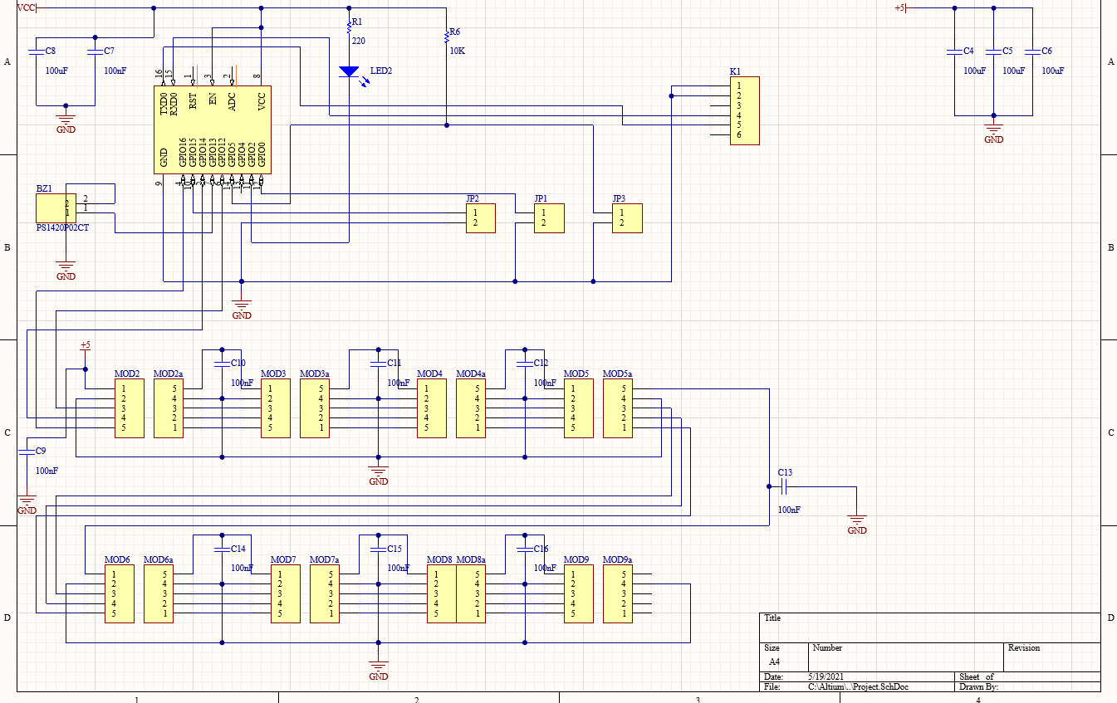

Fig.2 Electrical schematic

Figure 2 shows the used electrical schematic to make the device.

### PCB design

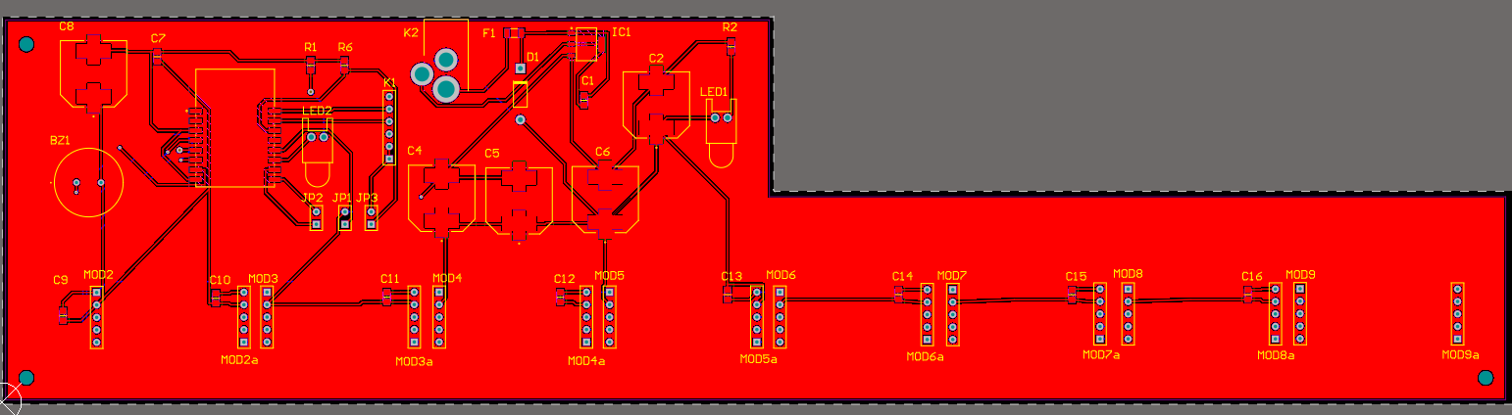

Fig.3 PCB design

Figure 3 shows the used PCB design for the device

### Finalized mechanical design

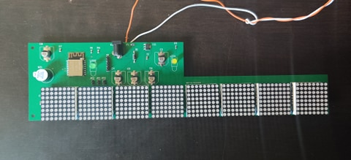

Fig.4 finalized mechanical design

Figure 4 shows the finalized mechanical design of the project.

# Discussion

[Reflect on and discuss your project.

* Which difficulties did you encounter during the design process and why? How did you solve these issues?
* Reflect on the process: did things go as expected? Would you choose the same approach if you had to do the project all over again? Are there issues that still need to be fixed? How come?

**+/-300 words**]

During the process of designing and building the project I encountered some difficulties. On the start of designing with Altium I came in contact with a person who was tested positive with covid-19. I was in quarantine for a week so I couldn’t attend the classes on campus, so I did not understand Altium at the beginning. To solve this I asked the other students to help me and I asked the teacher to record the lessons so I could learn Altium from home.   
I encountered a difficulty when all the parts arrived and I noticed the part would not fit on the PCB board. The footprint I downloaded from the website of the firm did not match the part. When I noticed this I searched for an other part with the same technicalities but with a different footprint.  
Another difficulty I encountered is that I measured the place of a component wrong. The part did not fit precisely on the board. The part is now placed on the board but it is on a slight angle in comparison with the rest.

Some things did not go as expected and there still issues that need to be fixed. My design was not ready on time so I could not order it on time. When there was the opportunity to place all the components on the board I could not work on it because my board had not been arrived yet. So if I had to do the project all over again I would choose a different approach and start on time with the design and ordering the parts.

My project is not finished yet. I still need to program the ESP-12 module. Before I can start programming I need to wait on the UART/USB cable I ordered. I did not know that I needed this cable to be able to program the module.

# Reference list

[1]Elektor